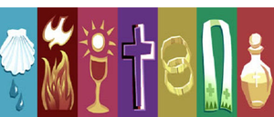
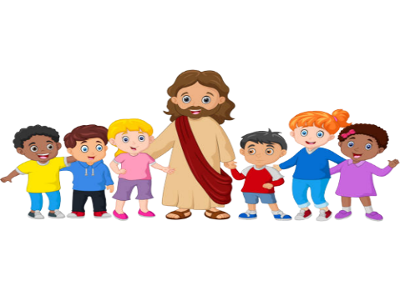
Session Schedule

DATE | SESSION | TIME | NOTES | QUESTION  OF THE DAY! | FUN FACTS!
Oct. 6  (Thursday) | Parent Meeting | 7:30 p.m. | Mass at 7:00 p.m.  Everyone welcome | What do we say when we make the Sign of the Cross? | Your family is called “domestic Church” because it’s the first place you learn about Jesus and your Catholic faith.
Oct. 16  (Sunday) | Session #1 | 9:30 a.m. |  | God blesses us all. Who have you blessed? | God created every one of us. He has a purpose for us all.
Oct. 30  (Sunday) | Session #2 | 9:30 a.m. |  | What does it mean to forgive your friends? | God never stops loving us, even when we sin.
Nov. 13  (Sunday) | Session #3 | 9:30 a.m. |  | Has there been a time that you made a mistake? Did you ask for God’s forgiveness? | By following the Ten Commandments, we learn to live God’s way and grow closer to him and others.
Nov. 26  (Saturday) | Session #4 & #5 | 2:00 p.m. – 4:00 p.m. |  | What have you done that could harm your relationship with God? | Priests wear stoles while celebrating Sacraments which shows they are acting in the person of Christ.
Dec. 4  (Sunday) | Session #6 | 9:30 a.m. | 2nd Sunday of Advent month | When was a time that you forgave a friend after they made you upset? | We are Jesus’s Body on Earth.
Dec. 5  (Monday) | Celebration of Sacrament of Reconciliation | 6:30 p.m. |  | Why must we admit our sins? | The priest cannot share our confession with anyone.
Jan. 8  (Sunday) | Session #7 | 9:30 a.m. |  | Why is it important to renew baptismal promises? | Fire is a sign of the Holy Spirit, which is burning in our hearts.
Jan. 22  (Sunday) | Session #8 | 9:30 a.m. |  | When has someone given you a gift by sharing their knowledge, time, or heart? | In the Sacrament of Confirmation, the Church calls upon the Holy Spirit to deepen our life in Jesus.
Feb. 4  (Saturday) | Session #9 &#10 | 2:00 p.m. – 4:00 p.m. |  | What does the Holy Spirit do for us in the Sacrament of Confirmation? | In the Old Testament, like today, they called the pouring or use of oil in a religious ceremony an anointing.
Feb. 19  (Sunday) | Session #11 | 9:30 a.m. |  | When are we welcomed into the Church family? | Jesus promised to never leave us.
Mar. 5  (Sunday) | Session #12 | 9:30 a.m. |  | What are some ways to show we are following Jesus by serving others? | The Holy Spirit gives us the grace to live as Jesus taught us.
Mar. 19  (Sunday) | Session #13 | 9:30 a.m. |  | Why is it important to listen to our loved ones? Why is it especially important to listen to Jesus? | Jesus is the Word of God.
Apr. 1  (Saturday) | Session #14 & #15 | 2:00 p.m. – 4:00 p.m. |  | Has there been a time where someone in your life made a sacrifice for you? | Sacrifice is a sign of love.
April 23  (Sunday) | Session #16 | 9:30 a.m. |  | From Baptism, we are given a mission to live and share the Good News of Christ. Who will you share it with? | God’s grace makes it possible for us to be his Body.
May 7  (Sunday) | MAKE UP DAY | 9:30 a.m. | For any sessions missed, families can come for this session. | Jesus keeps his promise to always be with us through the Sacraments. What are the Seven Sacraments? | At Baptism, your journey to life forever with God began.
May 28  (Sunday)  Pentecost | Extra Review Session before celebrations | 9:30 a.m. | Rehearsal | What does the word “Amen” mean? | Confirmation and First Eucharist will bring you even closer to Jesus, God the Father, and his Church.
June | Celebration of Sacrament of Confirmation and First Eucharist |  | Dates and times to be determined | How will you be changed after receiving these sacraments? | Baptism, Confirmation and  First Eucharist are the  three Sacraments of Initiation, through which we become full members of the Church.
